**Sci.calls**

* **Introduction**

The "Sci.calls" project is a totally new venture in education field. It's a new education center where the process of teaching & learning is conducted in completely different manner compared to what we are used to. The main goal of the project is to enhance the education system all around the world and play, at least, a minor role in the prosperity of mankind.

* **Work process**

From 1st to 4th grades as in any other secondary school, students attend the traditional classes where they are being consulted by an experienced mentor (teacher), given homework and learning new material. However, once the students reach the 5th grade they become a part of a program called "Sci.calls' Logic". This very program works based on **learn2** – learn in two discrepant meanings or, simply, “Learn through teaching” method.

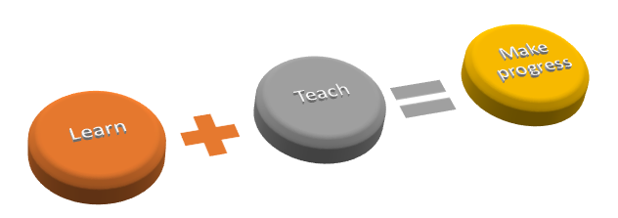

**Tabular presentation of Sci.calls' (Sci.calls’ Logic’s) work process:**

|  |  |  |  |
| --- | --- | --- | --- |
|  | Attend classes conducted by mentors | Attend classes conducted by high school students | Conduct classes for elementary school students |
| 1st-4th grades | **✓** |  |  |
| 5th-8th grades | **✓** | **✓** |  |
| 9th-12th grades | **✓** |  | **✓** |

"Sci.calls' Logic" is a special program which was designed specifically for the purpose of enhancing the quality of education all over the globe, handing out the opportunity of making best out of their study process to students (pupils).

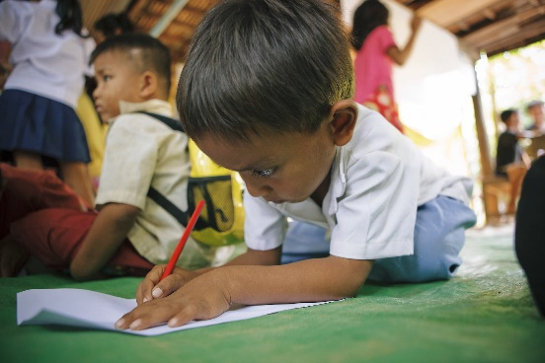

The process is conducted in the above shown way. As depicted in the table above, a group of students are chosen from 12th, 11th, 10th and 9th grades to give lessons to 8th, 7th, 6th and 5th grade students, respectively.

We believe that both parties are beneficiaries in this specific case. To be precise, the 9th grade, sophomore, junior and senior students benefit from this process as well as the elementary and middle school ones. They get to revise their knowledge and further cement it in their memory. Plus, they are handed an abundance of opportunities in exchange, that would be excessively useful in their studies as well as day to day life. On the other hand, the elementary and middle school students get a chance to gain some experience from the older students, while acquiring new knowledge.

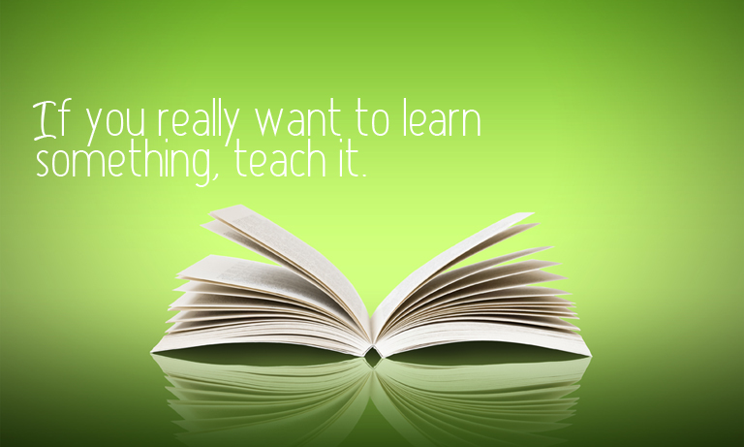

* **Issues “Sci.calls” is aiming to resolve**

“Problem” might be the most commonly used word all around the world. Therefore, we as “Sci.calls” decided to try to get to the roots of this phenomenon. And the best way to do this is to start making changes in education system, as this is where everything stems from. Our project would like to assist students in overcoming the obstacles and even turning them into new opportunities. Our main goal is to create an efficient education system, that enables students to have a strong psychological background as well as firm scholastic base. Our target is to solve great variety of important issues, like high violence rate among schoolchildren, lack of communication skills, generation gap, inability to compete, lack of knowledge to cope with serious life matters, lack of interest in education process and etc. We’re obliged to keep our students away from all these issues and show them the ways of dealing with those problems, in case of facing any.

“Our job is to help you build a great future and yet your job is to lay the first brick!”





We promise to work hard, just to see more of these smiling faces!

Here you can watch a short video about Sci.calls

**SCI.mp4**

**In case of having any additional questions or suggestions, feel free to leave a comment or contact us directly!**

**Email address: (Not compulsory!)**  
  
  
  
**Please, type your comment in the box below**  


**Our email address:** *sci.support@gmail.com*

**Identifying yourself, would help us with the improvements, even more** **(Not compulsory!)**

Elementary school student (Pupil)

High school student

Not a student

Parent

Other 

**Before submitting the form, please, make sure that it is correct! Then feel free to check the box below and submit the form.**

 *By checking this box, you confirm the truthfulness of the information provided by you*

 

**Thanks for your collaboration!**